Parallel & Distributed Computing

UCS645
Assignment - 3
Make File

Name – Pranav Chaudhary
Roll No. – 1023033320

System Environment: Linux (Ubuntu), GCC Compiler with OpenMP Support
AIM:
To learn how to write and use Make file.

Question: Calculate the correlation between every pair of input vectors (given m input vectors, each with n numbers).
Using code :-
Using 2-D Array
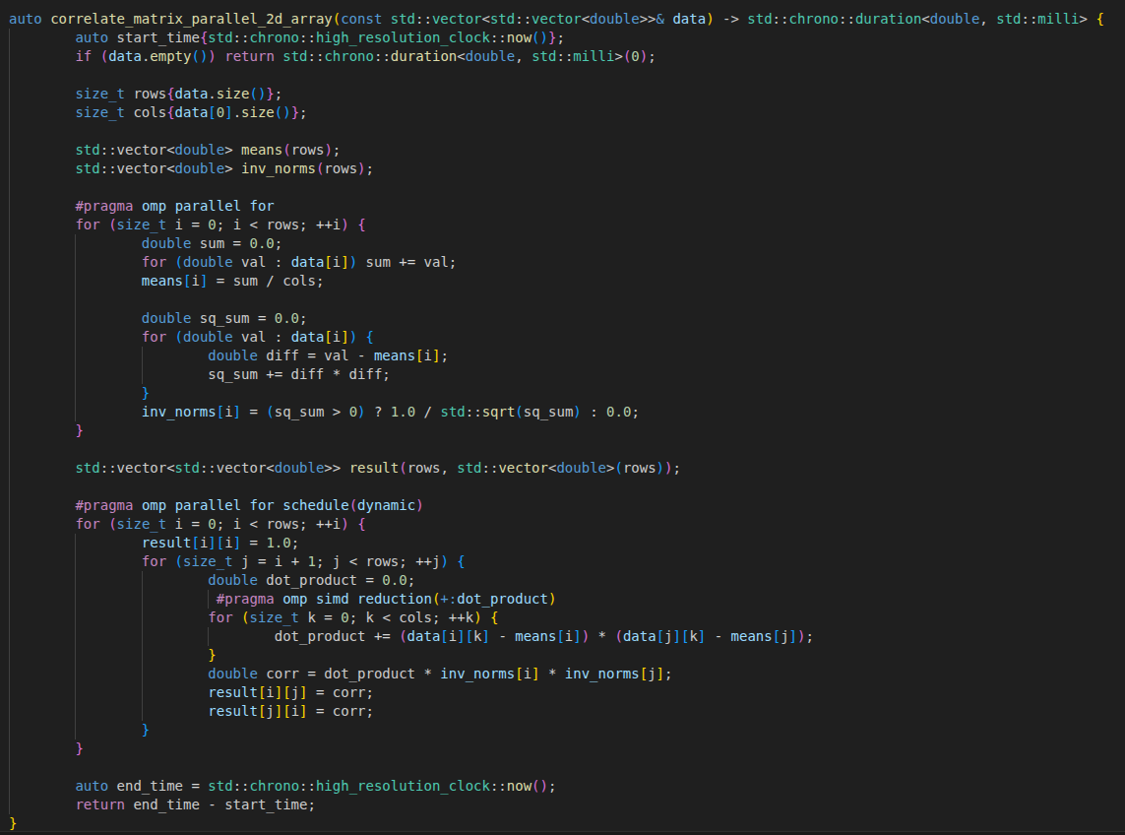

Using Flat Array

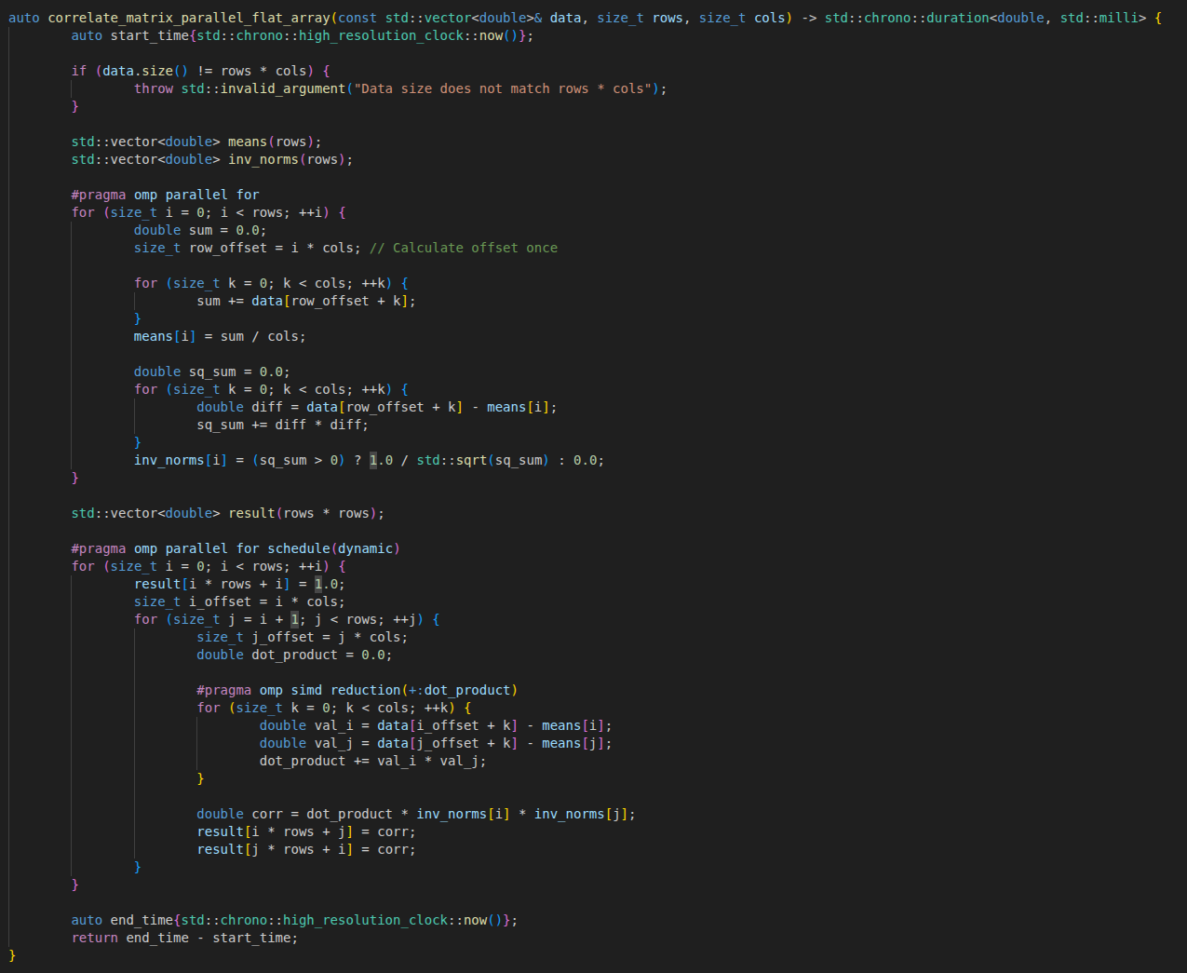

Using Make File:
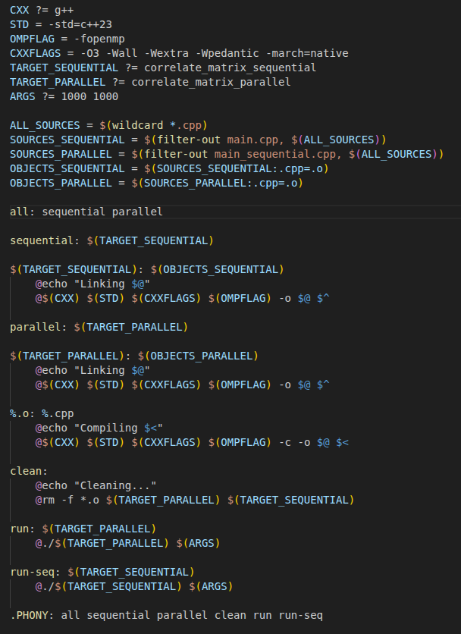

ON EXECUTION:-
1. Default Size 1000 x 1000 (Given in Make File “ARGS ?= 1000 1000”)
Threads | 2D Heap Array Time (ms) | 2D Heap Array Speed Up | Flat Array Time (ms) | Flat Array Speed Up
1 (Seq) | 434.94 | 1.00x | 434.94 | 1.00x
2 | 184.03 | 2.36x | 165.67 | 2.63x
4 | 89.74 | 4.85x | 86.37 | 5.04x
6 | 71.5 | 6.08x | 71.38 | 6.09x
8 | 61.25 | 7.10x | 68.15 | 6.38x

Table 2: Large Scale Input (ARGS="1200 1200")
(Demonstrates performance scaling on the largest dataset tested)
Threads | 2D Heap Array Time (ms) | 2D Heap Array Speed Up | Flat Array Time (ms) | Flat Array Speed Up
1 (Seq) | 762.21 | 1.00x | 762.21 | 1.00x
2 | 308.16 | 2.47x | 287.28 | 2.65x
4 | 147.9 | 5.15x | 150.23 | 5.07x
6 | 122.23 | 6.24x | 121.4 | 6.28x
8 | 110.45 | 6.90x | 111.43 | 6.84x

Table 3: Small Scale Input (ARGS="50 50")
(Demonstrates overhead where threading negatively impacts performance)
Threads | 2D Heap Array Time (ms) | 2D Heap Array Speed Up | Flat Array Time (ms) | Flat Array Speed Up
1 (Seq) | 0.06 | 1.00x | 0.06 | 1.00x
2 | 0.14 | 0.41x | 0.06 | 0.99x
4 | 0.07 | 0.82x | 0.03 | 1.80x
6 | 0.05 | 1.06x | 0.43 | 0.14x
8 | 0.98 | 0.06x | 0.99 | 0.06x

INFERENCE:-
For the 50 x 50 matrix, the speedup is actually a slowdown. We see values like 0.06x, which means the parallel version is significantly slower than the simple sequential one.
This happens because the computer takes a small amount of time to create threads and assign work to them. For a tiny 50 x 50 matrix, the math is finished in a fraction of a millisecond ($0.06ms$). If the time it takes to manage the threads is longer than the time it takes to do the math, adding more threads just adds more weight without any benefit.
The 1000 x 1000 matrix shows the most impressive results, reaching a peak speedup of 7.10x with 8 threads.
At this size, the amount of work is large enough to keep many threads busy, but the data is likely sized perfectly to maximize the CPU's cache usage. Because the CPU doesn't have to wait as often for the slower main RAM to send data, the speed scales beautifully as we add more threads. We even see "super-linear" scaling (where 4 threads give $>4x$ speedup), suggesting the smaller per-thread chunks fit better in the fast L1/L2 cache than the single large sequential chunk did.
As we move to the 1200 x 1200 matrix, the speedup remains strong (around 6.90x) but shows slight signs of leveling off compared to the 1000x1000 tests.
This typically occurs because we begin approaching the physical limit called memory bandwidth. Even though we have 8 threads ready to calculate, they all have to share the same path to the system's RAM. At larger scales, the CPU cores may occasionally sit idle while waiting for the RAM to deliver the next set of numbers.
The data compares:
- 2D array implementation (arrays of arrays) can sometimes be scattered in different parts of the memory, requiring "pointer chasing."
- Flat Array implementation (a single long list) usually performs more consistently because it is more cache-friendly.
When data is flat, the CPU can predict what we need next and pre-load it (prefetching). In your Default 1000x1000 results, the Flat Array was generally faster in the lower thread counts (e.g., $165ms$ vs $184ms$ for 2 threads) because the contiguous memory organization helps the processor read data more efficiently.
The Makefile is doing a lot of the heavy lifting behind the scenes.
- The -O3 Flag: This tells the compiler to go into high-gear and rewrite your code to be as fast as possible, such as unrolling loops.
- The -march=native Flag: This is a crucial setting. It tells the compiler to look at the specific CPU and use its specialized hardware instructions (like AVX). This allows the CPU to process multiple numbers at the exact same time (SIMD), which is why we see such high speedups in the mid-sized matrices.
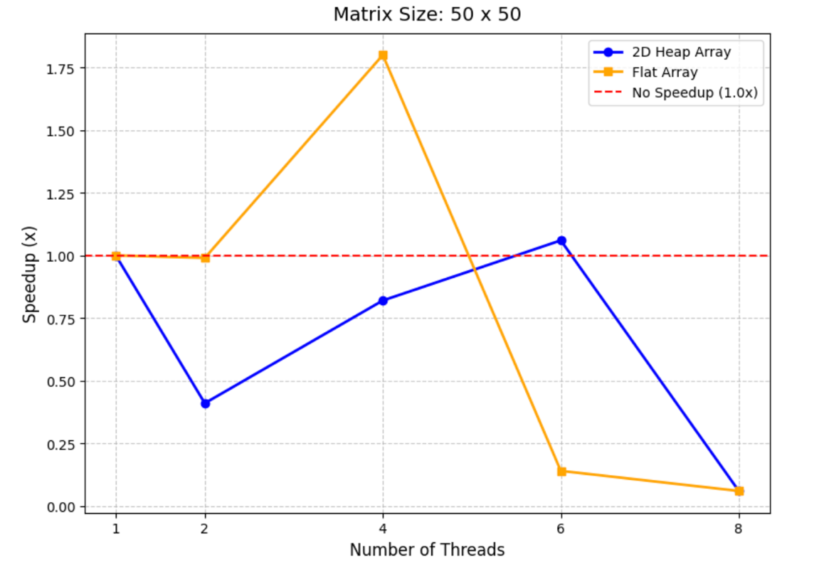

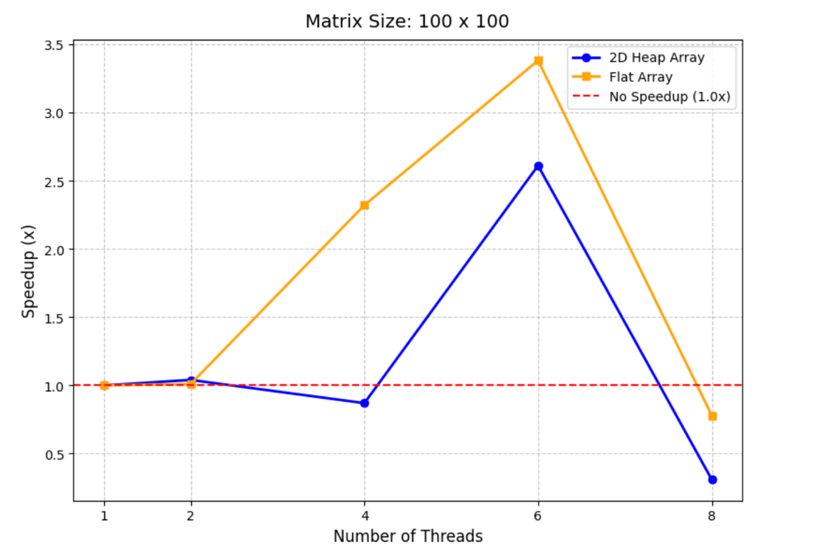

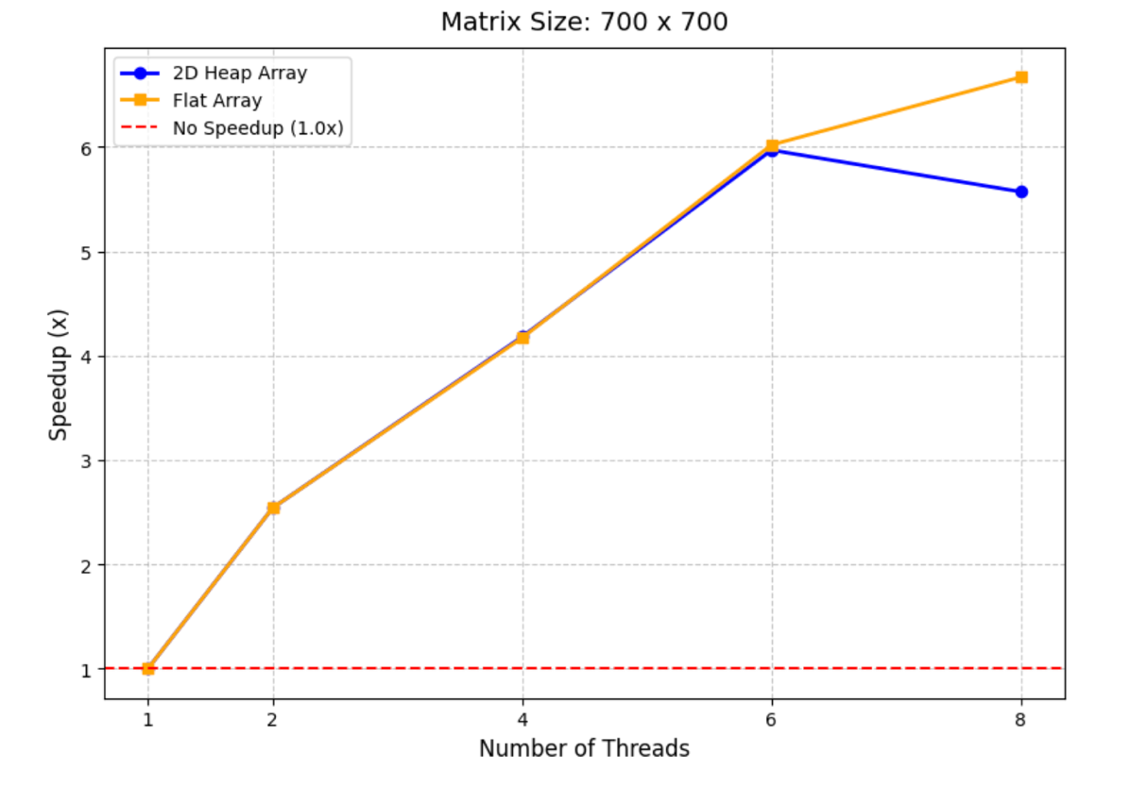

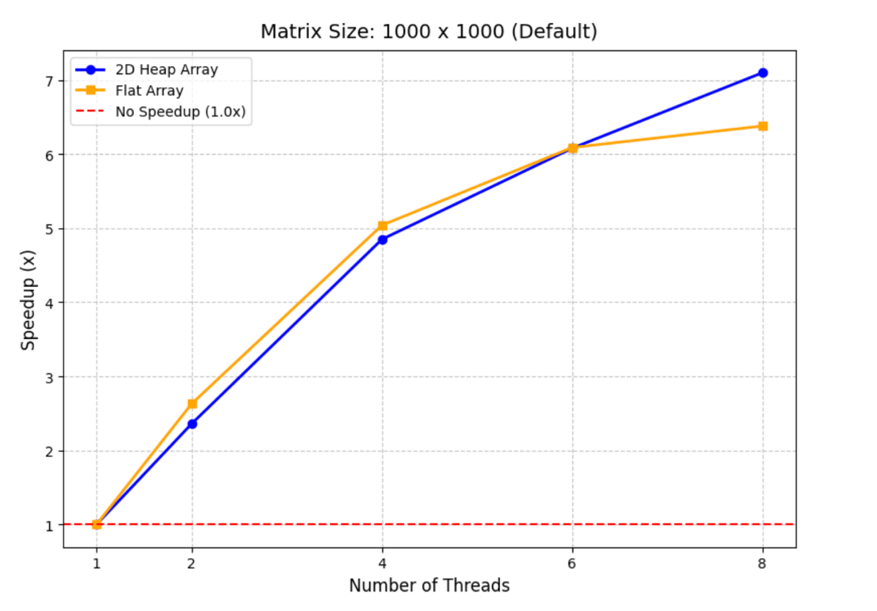

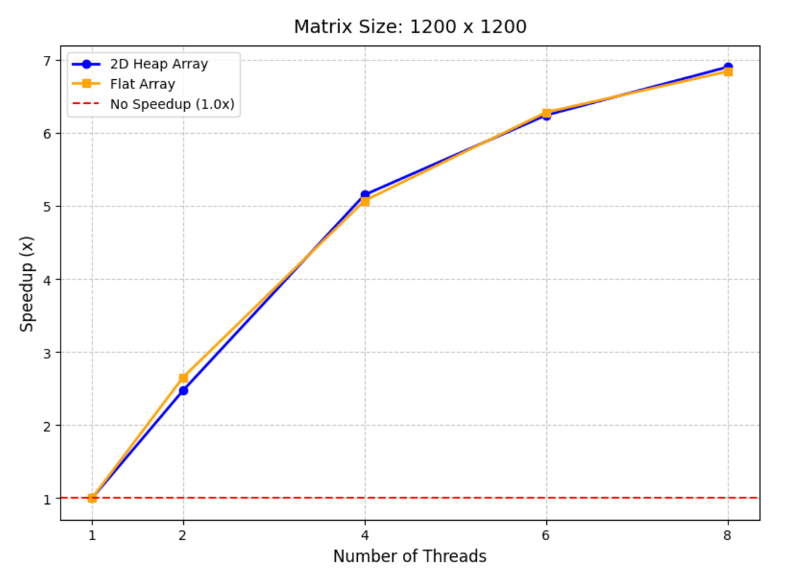

Perfstat Inference :-

1. Sequential Execution:

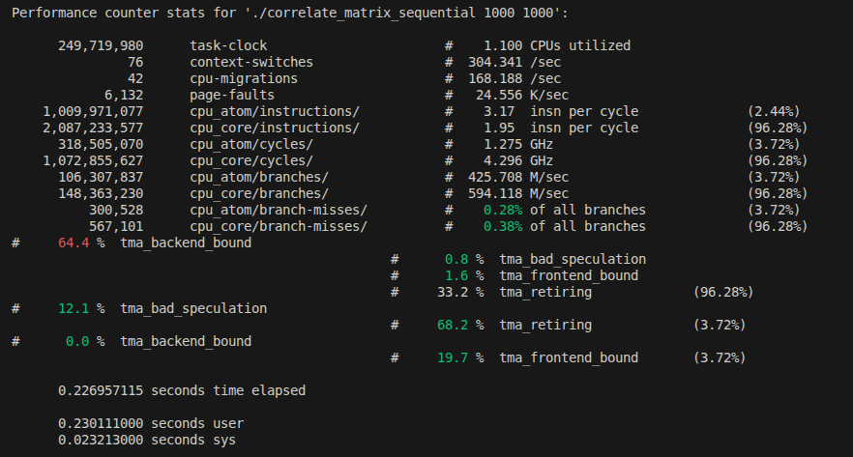

1. Resource Utilization:-
Strictly Sequential: With only 1.100 CPUs utilized, this application is entirely single-threaded. The task-clock time (249.71 ms) almost perfectly mirrors the elapsed physical time (226.95 ms), meaning the program is restricted to a single core and is ignoring the rest of the multi-core system.
P-Core Dominance: The operating system effectively routed this single-threaded workload to the fast Performance-cores, which handled 96.28% of the execution time while boosting to an impressive 4.296 GHz. The Efficiency (Atom) cores saw negligible use (3.72%), likely just handling brief background OS tasks or thread initialization.
2. Instruction Efficiency:-
P-Core Performance: The Performance cores achieved a solid IPC (Instructions Per Cycle) of 1.95, successfully retiring 33.2% of their operations without stalling.
Highly Predictable Logic: Branch prediction is near-perfect, with miss rates at a tiny 0.38% on P-cores and 0.28% on E-cores. Because matrix operations rely on highly repetitive, standard nested for loops, the CPU has absolutely no trouble guessing the control flow.
3. Primary Bottlenecks:-
Memory Starvation (64.4% Backend Bound on P-Cores): Despite running at high clock speeds and predicting branches perfectly, the P-cores spend nearly two-thirds of their execution pipeline completely stalled in the backend. Matrix correlation requires continuously fetching large rows and columns of data. The CPU's arithmetic units are processing the math much faster than the RAM/cache can supply the data, leaving the processor starved and waiting.
The Single-Thread Limit: Outside of the memory stalls, the biggest absolute bottleneck to the execution speed is the lack of parallelization. Because it is only utilizing 1 CPU, the overall performance is hard-capped by the single-core clock speed (4.296 GHz) and cannot scale, no matter how much compute power the rest of the machine has.

2. Parallel Execution:
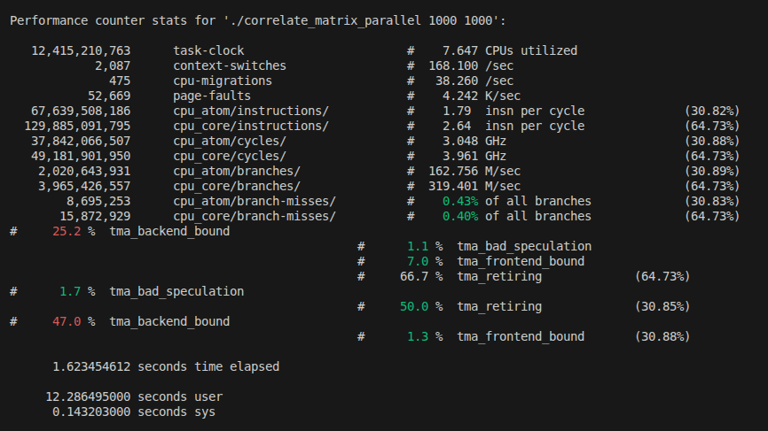

1. Resource Utilization:-
Parallel Efficiency: With 7.647 CPUs utilized, the system is successfully parallelizing the workload. It condensed over 12.4 seconds of total computational work (task-clock) into just 1.62 seconds of real-world elapsed time.
Hybrid Execution: The workload is effectively distributed across the hybrid architecture. The Performance-cores are boosting to ~3.96 GHz and handling the majority of the heavy lifting (taking up ~64.7% of the total cycles), while the Efficiency-cores are actively contributing at ~3.05 GHz.
2. Instruction Efficiency:-
Exceptional P-Core Performance: The Performance cores achieved an outstanding IPC (Instructions Per Cycle) of 2.64. Even more impressive is the 66.7% retiring rate. This means exactly what we want to see in a compute heavy task: the fast cores are churning through the math with very few stalls.
Solid E-Core Contribution: The Efficiency cores also performed remarkably well, maintaining an IPC of 1.79 and successfully retiring 50.0% of their instructions.
Perfect Branch Prediction: The predictable nature of nested for loops means the CPU rarely guesses the wrong path. Branch misses are practically non-existent at 0.40% (P-cores) and 0.43% (E-cores).
3. Primary Bottlenecks:-
Memory Starvation (25.2% Backend Bound on P-Cores): This is the biggest victory of the parallel implementation. By parallelizing the code we have drastically reduced memory starvation. The execution units are finally getting the data fed to them fast enough to keep busy.
Moderate E-Core Backend Bound (47.0%): Efficiency cores are spending about half their time waiting on memory, which is expected since E-cores typically have smaller localized caches and less memory bandwidth than P-cores.

3. Comparison between sequential and parallel:

1. Resource Utilization & Core Scaling
Hardware Saturation: The sequential code behaved exactly as expected, utilizing 1.100 CPUs and relying almost entirely on a single Performance-core boosting to 4.296 GHz. The parallel version successfully distributed the workload, utilizing 7.647 CPUs and effectively splitting the operations between P-cores (64.7%) and E-cores (30.8%).
2. Pipeline Efficiency:
Memory starvation: The parallel code is structurally much better optimized for the hardware cache. The sequential version was severely memory-starved, suffering a 64.4% Backend Bound stall rate on the P-cores. The parallel version slashed this memory bottleneck down to just 25.2%.
Instruction Throughput: Because it wasn't waiting on memory, the parallel version saw its P-core retiring rate double (from 33.2% to 66.7%) and its IPC jump from a respectable 1.95 to an outstanding 2.64.

